Older Citizens Advocacy – York
(OCAY)

Longer Term Impact Survey
Pilot - June 2021

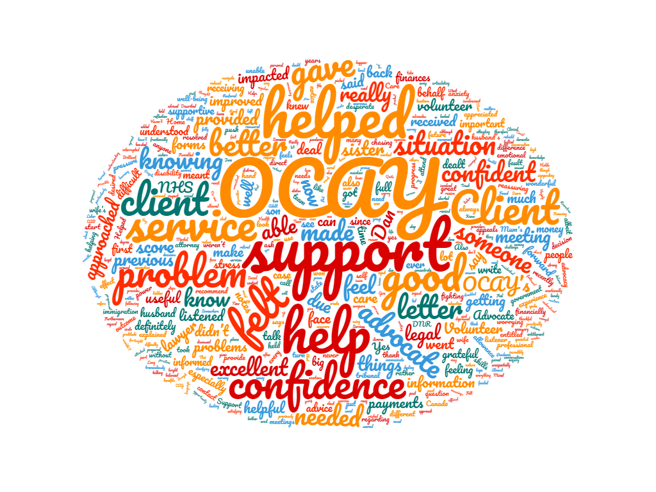
Word cloud created with descriptive explanations provided by questionnaire participants.

Report and summary of results

Methodology
A team of volunteers and OCAY staff members formed a working group to develop the questionnaire, a script, and the method of delivery. The script and questionnaire were drafted to enable a degree of consistency in how longer-term impact was to be explored. Idea development took place via Zoom and email. Once the questionnaire and script were finalised (appendix 1), a sample of 30 clients were selected at random to be interviewed. All the cases had been closed between six and 12 months before the interviews took place. A team of five volunteers used the script and questionnaire to undertake the survey over the telephone in May 2021. The volunteers who carried out the survey had not worked with the clients previously. This was decided to be the most appropriate way of gathering responses to enable participants to answer the questions honestly. A letter was sent to each client informing them of the survey (appendix 2), when they would be contacted, and by whom. The letter also explained how to let OCAY know if they did not want to take part. Consent for contact was gathered when clients initially accessed the service. Clients’ details were not recorded along with their responses meaning they were fully anonymous.

Results
A total of 18 clients completed the questionnaire which resulted in a 60% response rate. The clients who did not participate in the questionnaire were either unable to remember working with OCAY or did not answer the telephone when called.

Question 1 and 2
‘On a scale of 1 to 10, with 1 meaning it has had no impact and 10 meaning it has had a huge impact; how would you say OCAY’s support has impacted your well-being over the past 6 months?’

All participants responded to this question, with 16 giving a score of 7 or above in relation to OCAY’s support having an impact on their well-being over the past 6 months; two scored a 5; and no participants gave a score of 4 or less.
When asked to explain the reason why a participant gave their score on the scale, those scoring the service as having had an impact on their well-being as a 7 or above stated things such as:
- Having the support from OCAY made them feel like ‘a more content and happier person’.
- Using the service ‘made their life easier’.
- The problem had caused a lot of anxiety over a number of years and OCAY made a big difference because someone listened and helped them make some headway.
- It was the professional nature of the letter from OCAY that made the difference and was very grateful.
- OCAY provided morale support and confidence.
- The service ‘held their hand’.
- OCAY was ‘a wonderful service’.
- Only used [OCAY] for a short time due to COVID-19 – very good.

Those who gave a score of 5 mentioned they had not needed to use the service recently due to previous support given; and that although OCAY were unable to provide help with their particular issue, the knowledge gained from the service meant they were better informed about their situation.

Question 3 and 4
‘On a scale of 1 to 10, with 1 meaning it has had no impact and 10 meaning it has had a huge impact; how would you say OCAY’s support has impacted your confidence over the past 6 months?’

Again, all participants responded to this question; with 14 scoring a 7 or above in relation to how OCAY’s support had impacted their confidence over the past 6 months; 1 providing a score of one on the scale; and 3 giving a score of 5.
When asked why the participants gave this score, those scoring 7 or above provided explanations such as:
- Client says she was left feeling she could always ask OCAY, as she is very confident now after receiving such good advocacy. Client was happy to talk about her worries especially as the advocate was a good listener.
- Client confident with OCAY, especially as the advocate listened and provided practical support.
- Support was important - knowing someone was there gave confidence.
- They had the best help and feels as though they would ask OCAY for help in future.
- OCAY’s support helped them to rebuild their confidence in the NHS.
- Service was excellent, supportive, and consistent.
- OCAY helped greatly.

When those who scored a 5 were asked why they had chosen their score, they explained:
- The client is not a very confident person, and the score was more of a reflection of them than OCAY.
- That as a result of OCAY’s support, they were confident they knew the facts of the situation and that there was nothing they could reasonably do.
- Although usually very confident, due to experiencing a lot of stress they were feeling under par so the support provided by OCAY provided the boost needed to deal with the situation.

The participant who gave a score of 1 explained that they did not think the question was relevant to the problem for which they sought help.

Question 5a
‘Have you felt any long-term benefits from your support from OCAY in terms of financial matters?’

All participants provided an answer for this question, with 9 saying they did feel long-term benefits from OCAY’s support in relation to financial matters and 9 saying they did not.
Those who answered ‘Yes’ to this question were asked to describe these benefits with participants stating that:
- Seeking advice from OCAY, rather than a solicitor, meant they had not incurred any costs.
- OCAY gave them more confidence to push forward their own ‘good dialogue’ about payments they should have been received which ultimately impacted positively on their finances.
- Definitely because they got the money back and continued to receive the payments they were eligible for, meaning they were financially better off.
- OCAY’s support helped the client look after their sister and helping with disability allowance appeals helped the client’s sister look after herself.

Question 5b
‘Have you felt any long-term benefits from your support from OCAY emotionally?’

All but one of the participants answered this question (17 responses), with 15 of them stating they did feel long-term benefits from their support from OCAY emotionally and 2 saying they did not.
Those who responded ‘Yes’ to this question were asked to describe how they were impacted emotionally, and they described the following:
- OCAY alleviated their emotional distress which was particularly acute.
- After the problem progressed, they could see how OCAY’s support had helped emotionally as they had shut down their emotions and was very depressed.
- OCAY’s support helped reduce their anxiety.
- Their emotional health improved because OCAY’s support meant they didn’t have to keep worrying about chasing this up themselves and getting more and more annoyed with each phone call.
- The volunteer picked up on what was important to them.
- The volunteer gave them confidence to challenge the status quo and provided support when needed.
- Their feeling of well-being was much improved following help from OCAY. Very relieved to realise someone is there to help, especially during the difficult pandemic.
- It was good to feel that they had someone in their corner.

Question 5c
‘Have you felt any long-term benefits from your support from OCAY practically?’

17 participants answered this question, with 10 clients believing that they felt long-term benefits from the support from OCAY practically and 7 saying they did not feel any practical long-term benefits.

Those that answered ‘Yes’ to this question were asked why they gave this answer and the following explanations were provided:
- Their roof problem was resolved.
- Client felt armed with as much information as possible and was able to put forward a strong case therefore feeling more prepared resulting in their son winning the right to have supported residential care.
- OCAY provided the information needed to make the next steps, leading them to further service providers that helped with their situation.
- OCAY’s support helped their sister get looked after to the degree that they needed.
- Signposting was useful. Described themselves as feeling ‘sunny side up now’ and knew that if they had any bother, OCAY could provide support.

Question 5d
‘Have you felt any long-term benefits from your support from OCAY with anything else?’

Of the 18 participants, 16 responded to this question with 12 saying they did feel long-term benefits from the support from OCAY with other aspects of their lives and 4 saying they did not.
Of those who thought the support from OCAY had long-term benefits on other aspects of their lives, they explained that:
- They were reassured knowing that if they ever approached OCAY with a problem they have the skills within their team to help.
- The help received from OCAY gave them hope.
- They were grateful for having someone to talk to and by getting things off their chest and articulating their problem to someone else, they felt better.
- The main thing for him was having someone to talk to (or communicate with by email). By getting things off his chest and articulating his problem to someone else, he felt better. He was thankful that the service was there.
- OCAY meant there was someone there to listen, help to hone in on the important things, and funnel information. They had restored confidence as they always thought they were bright until having to deal with government forms – reassured to know that the forms are difficult and requires know how.
- They had first approached the Citizens Advice Bureau but they were not able to help with their problems.

Question 6
‘If you had a problem in the future, would you go back to OCAY for help?’

All but one of the participants answered this question (17 responses), and they all said they would go back to OCAY in the future for help.

Conclusions
The responses were very favourable, participants appreciated the service and were extremely grateful for the support OCAY had provided. This is demonstrated by 100% of those answering the question (and 94% of the total sample who participated) saying that they would come back to OCAY for help in the future if they had a problem.
The responses to questions 1 and 3 demonstrate that the majority of participants (scoring 7 or above) felt that working with OCAY did have an impact on their well-being and confidence over the past six months. The reasons provided to explain the level of the score help us to understand why this was. Participants giving a lower score identified other issues that had also impacted on their well-being and confidence.
The responses to question 5 may have been better understood if participants were asked to identify a support category at the beginning of the survey i.e., family, health/care, housing, consumer issues, finance, employment, benefits etc. This may have helped us to understand whether participants answered ‘No’ to these questions because their support did not relate to the question; or whether it did relate to the question, but they did not feel any long-term benefit in those areas. Understanding this may allow us to better identify areas of service improvement. Piloting the questionnaire is an important process to identify questions that work well, and ways in which they could be asked in a better way. Further development of the questionnaire could be implemented in future to better capture responses. However, participants did provide evidence of the longer-term impact of working with OCAY relating to continued improvement in financial matters, emotional well-being and confidence.
Key themes emerged when participants answered open-ended questions (allowing them to respond in their own words) in relation to OCAY and its service provision. These themes were being listened to, confidence building, useful signposting, appreciating the skills advocates had, and information provision. These themes link back to the outcomes we report on quarterly; improved sense of control over the situation, having been taken more seriously, feeling their voice has been heard more and the issue is having less of an impact on their wellbeing. A general sense gained from these responses leads one to think that use of the service empowered the majority of these participants in some way or another.
The pilot has been a useful exercise and has helped us to gain some useful insights into the longer-term impacts of working with OCAY. The questionnaire can be developed to pick up the points made above and the survey could be undertaken every six months to help us to build on these insights and aid service improvements.

Acknowledgements

We would like to thank the clients who agreed to participate in the questionnaire. We would also like to thank the volunteers who undertook the survey and helped to produce this report.

Appendix 1 – Script & Questionnaire

Long Term Impact Survey and script
Hello, I am a volunteer from OCAY calling to talk to you about a short survey looking at OCAY’s advocacy service and how it has helped you. You will have had a letter that explained we would be contacting you. The survey will be used to help improve the service and your responses will be kept confidentially and reported anonymously. We are very grateful for your help.
- On a scale of 1 to 10, with 1 meaning it has had no impact and 10 meaning it has had a huge impact; how would you say OCAY’s support has impacted your well-being over the past 6 months?

- 2 3 4 5 6 7 8 9 10

- Could you please explain why you gave this score on the scale?’

- On a scale of 1 to 10, with 1 meaning it has had no impact and 10 meaning it has had a huge impact; how would you say OCAY’s support has impacted your confidence over the past 6 months?

1 2 3 4 5 6 7 8 9 10

- Could you please explain why you gave this score on the scale?’

- Have you felt any long-term benefits from your support from OCAY in terms of …?
  - Financial matters YES ☐ / NO ☐

    - If yes. Please can you describe that?

  - Emotionally YES ☐ / NO ☐
    - If yes. Please can you describe that?

  - Practically YES ☐ / NO ☐
    - If yes. Please can you describe that?

  - Anything else YES ☐ / NO ☐
    - If yes. Please can you describe that?

- If you had a problem in the future would you go back to OCAY for help?

YES ☐ / NO ☐
Thank you for your help today, we really appreciate it.

Appendix 2 – Letter sent to clients ahead of data collection.

