Older Citizens Advocacy York (OCAY)
Longer-Term Impact Survey
March/April 2024

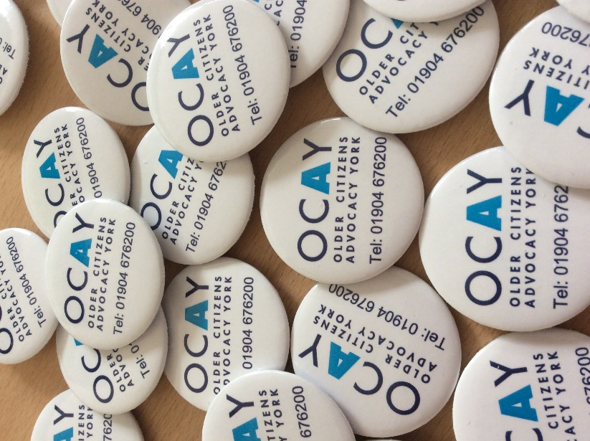

Report and summary of results

Methodology
The intention of this longer-term impact survey is for it to be carried out every 6 months or so as an ongoing measure of how our clients are viewing our services, and to highlight any areas of improvement.
This was the fourth long-term impact survey we had conducted since the start of 2022. Two previous surveys were held in 2022 and one in 2023. Based on our experiences of carrying out the previous surveys, slight changes were made to the script to increase ease of understanding for the respondents and to gather more information on the initial thoughts and lasting impressions of OCAY. The amended script is included as an Appendix with a note of the changes from the previous survey.
A sample of thirty clients were selected at random to be interviewed. All the cases had been closed between four and 12 months before the interviews took place. Two advocates agreed to use the script to undertake the survey over the telephone in March 2024.
The advocates who carried out the survey had not worked with the clients previously. This was decided to be the most appropriate way of gathering responses to enable participants to answer the questions honestly. A letter was sent to each client informing them of the survey, when they would be contacted, and by whom. The letter also explained how to let OCAY know if they did not want to take part. Consent for contact was gathered when clients initially accessed the service. Clients’ details were not recorded along with their responses meaning they were fully anonymous.
Results
A total of 20 clients agreed to complete the survey which was same number of participants who agreed to take part in the 2023 survey. The clients who did not participate were either unable to remember working with OCAY, were ill, did not answer the telephone when called, or did not want to answer the questions.

The type of issues the participants approached OCAY about were in connection with benefits (7), blue badge (6), consumer (2), finance (2), health (1), pension (1)
and council tax (1).

There was variation in terms of whether each respondent answered all questions, and this is noted against each question below. The results of each question are broken down in graphs, where appropriate.

Question 1
Can you remember what your initial impression of OCAY was … what did you think we did?
19 people answered this question.
Comments included:
- ‘Absolutely brilliant’ (twice).
- ‘Couldn’t have done without you’.
- ‘Very professional, explained everything’.
- ‘Very good, helpful, organised’.
- ‘Impressed with the speedy way [they] helped me’.
- ‘Good, friendly, pleasant’.

Question 2 and 3
‘On a scale of 1 to 5, with 1 meaning it has had no impact and 5 meaning it has had a huge impact, how would you say OCAY’s support has impacted your well-being over the past 6 months?’

20 participants responded to this question: 16 people gave a score of 5, and 4 people gave a score of 4.
When asked to explain the reason why a participant gave their score on the scale, comments included:
- ‘Very helpful’.
- ‘Knowing someone on your side, understands’.
- ‘Outstanding’.
- ‘I knew [I was] speaking to someone knowledgeable’.
- ‘Advocate very thorough and polite, felt listened to’.
- ‘Advocate was great, was getting worried, felt better’.
Question 4 and 5
‘On a scale of 1 to 5, with 1 meaning it has had no impact and 5 meaning it has had a huge impact; how would you say OCAY’s support has impacted your confidence over the past 6 months?’

16 participants responded to this question: 12 people gave a score of 5, and 4 people gave a score of 4. Four people decided not to answer or felt it was not applicable to them.
When asked to explain the reason why a participant gave their score on the scale, they stated things such as:
- ‘Brilliant’.
- ‘Been there for me’.
- ‘Confident would succeed’.
- ‘Still suffer with lack of confidence, cope a bit better, realise there is someone to call’.
- ‘Felt better it was sorted out’.

Question 6a
Have you felt any long-term benefits from your support from OCAY in terms of financial matters?’

20 participants provided an answer to this question, with 15 saying they did feel long-term benefits from OCAY’s support in relation to financial matters; 4 saying that they did not; and 1 person was unsure.

Those who answered ‘Yes’ to this question were asked to describe these benefits with participants stating that:

- ‘Got me such a good deal’.
- ‘All got sorted in end’.

During these conversations, it was identified that 3 people said they were helped to get an increase in income by getting Attendance Allowance, 2 people got an increase in income by getting Personal Independence Payment, and 1 person got a Blue Badge for parking.

Question 6b
Have you felt any long-term benefits from your support from OCAY emotionally?

18 participants answered this question, with 16 of them saying that they did feel long-term benefits after their support from OCAY emotionally; and 2 saying that they did not.

Those who responded ‘Yes’ to this question were asked to describe how they were impacted emotionally, and they described the following:

- ‘Just knowing someone is official when complaining’.
- ‘Someone who doesn’t know you but helping – gives a boost to know this’.
- ‘It has, [made me] realise [I’m] not alone, there are people who can help’.
- ‘Very good’.
- ‘Support so important’.

While discussing the long-term emotional benefits after their support from OCAY, a few people mentioned that they felt better; and one participant said the help was ‘lovely’ and set client at ease.

Question 6c
Have you felt any long-term benefits from your support from OCAY practically?

16 participants answered this question, with 15 of them saying that they did feel long-term benefits from their support from OCAY practically; and 1 saying that they did not.
Those who responded, ‘Yes’ to this question were asked to describe how they were impacted practically, and they mentioned things like appreciating that the help was ‘down to earth’ and the freedom OCAY provided through their support and that they ‘got [the] right help and support’.

Question 7

Please can you tell us what would have happened if you didn’t receive OCAY’s support?

17 people responded to this question. Comments included:

- ‘Would have got distressed’.
- ‘I would have had to do things myself’.
- ‘Couldn’t have done without [OCAY]’.
- ‘Given up’.
- ‘Found it more difficult’.
- ‘Depression twice as bad, not got Personal Independence Payment’.
- ‘Made life more miserable’.
- ‘Wouldn’t have got Attendance Allowance’.
- ‘Spiralled down emotionally, depression, not known which way to turn’.
- ‘Savings would have dwindled to nothing’.

Question 8
If you had a problem in the future, would you go back to OCAY for help?

20 participants answered this question with all of them saying that they would go back to OCAY for help.
Question 9
Would you recommend OCAY to friends?

20 participants answered this question and all of them said they would recommend OCAY to friends.
Question 10

How would you describe OCAY to friends?

17 people responded to this question. Comments included:

‘Sort out problems with officialdom.’
‘I have told my friends how helpful you have been.’
‘Best people possible, you can get in touch.’
‘Get in touch, very, very helpful.’
‘Effective help.’
‘Generally, all round knowledgeable about help available, support and advice.’
‘Recommend … would get sensible answer.’
‘Understanding and supportive.’

Conclusions

Overall, the responses provided were very positive. For question 2, 100% scored 4 or higher in terms of their experience with OCAY having impacted their well-being; for question 4, 80% scored 4 or higher in relation to OCAY’s support having impacted their confidence; for question 6, 75% said they believe they felt long-term benefits financially and practically; and 80% said they felt long-term benefits emotionally. This demonstrates how OCAY’s work can benefit people in all areas of their lives.

Based on the comments provided in relation to the scores given, it appeared that people really appreciated the support they had received. The most significant results were that 100% of respondents said that they would go back to OCAY for help in the future and would also recommend OCAY to their friends. This demonstrates that the clients were happy with their experience, and the fact those respondents who had answered ‘No’ to them feeling long-term impact financially, emotionally, or practically indicates that these responses could have been due to the type of case the client was helped with rather than the service not having longer-term impact for them i.e. supporting with a health-based issue wouldn’t necessarily result in a financial impact. As the responses are fully anonymous, it is not possible to link their type of case to their answers so this cannot be explored. However, it may be possible to ask this in future surveys so this can be examined in more detail.

Some of the clients did not appear to understand some of the questions, for example some of the responses to question 1 seem to relate more to their experience with OCAY or their current opinion rather than their initial impression. This indicates that it may be useful to revisit the wording or inclusion of this question for future surveys.

The 2023 survey highlighted the challenges there can be to manage expectations with clients. This feedback was taken on board by the advocacy team and more effort has been made to make sure expectations are carefully managed. For example, at initial assessments we are careful to be realistic with clients about potential outcomes. This seems to have worked as this sample of clients demonstrates that people are content with the support provided.

The surveys that were completed reflect the most common types of cases that OCAY deal with over a typical year; with 35% of the surveys being completed by clients who approached the service for help with benefits (our most common issues) and 30% of the surveys being completed by clients who wanted help with Blue Badge applications.

The results of this survey highlight that the services provided by OCAY are delivering an important resource to its clients. This demonstrates that continuing with longer-term impact assessments with previous clients acts as a good way to measure that OCAY provides the high-quality support as it is intended.

The results of this report will be shared with trustees, volunteers, and staff. The learning will therefore be shared throughout the organisation.

Appendix
The following changes have been made from the 2023 script:
- The scales on questions 2 and 4 have been changed from 1 to 10 in the 2023 survey to 1 to 5.

- Questions 1, 9 and 10 are new questions. They were not used in the 2023 survey.
Long Term Impact Survey and script (2024)
Hello, I am an advocate from OCAY calling to talk to you about a short survey looking at OCAY’s advocacy service and how it has helped you with…… (add here the issue/s that the client had support with).
You will have had a letter that explained we would be contacting you. The survey will be used to help improve the service and your responses will be kept confidentially and reported anonymously. We are very grateful for your help.
- Can you remember what your initial impression of OCAY was…what did you think we did?

- On a scale of 1 to 5, with 1 meaning it has had no impact and 5 meaning it has had a huge impact; how would you say OCAY’s support has impacted your well-being over the past 6 months?
- 2 3 4 5

- Could you please explain why you gave this score on the scale?’

- On a scale of 1 to 5, with 1 meaning it has had no impact and 5 meaning it has had a huge impact; how would you say OCAY’s support has impacted your confidence over the past 6 months?
1 2 3 4 5
- Could you please explain why you gave this score on the scale?’

- Have you felt any long-term benefits from your support from OCAY in terms of …?
  - Financial matters YES ☐ / NO ☐

If yes. Please can you describe that?

  - Emotionally, YES ☐ / NO ☐

If yes. Please can you describe that?

  - Practically YES ☐ / NO ☐

If yes. Please can you describe that?

  - Anything else YES ☐ / NO ☐

If yes. Please can you describe that?

- Please can you tell us what would have happened if you didn’t receive OCAY’s support?

- If you had a problem in the future would you go back to OCAY for help?
YES ☐ / NO ☐
- Would you recommend OCAY to friends?
YES ☐ / NO ☐
- How would you describe OCAY to them?

Would you be willing to feature in a case study about the support you received?
If so would you be willing to receive a call from our new Trustee who is helping us with our marketing?

Thank you for your help today, we really appreciate it.

